Public Affairs Plan
August 2023

Overview
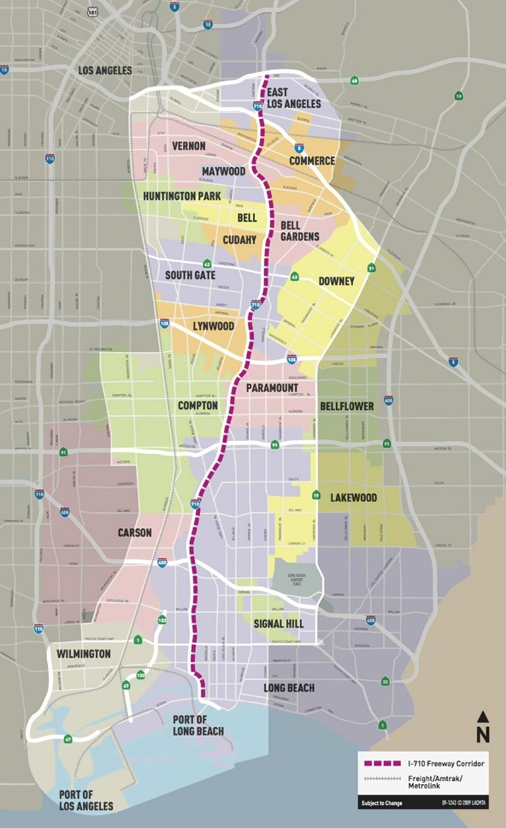
Figure 1 Long Beach to East LA Corridor
As part of Metro's efforts to enhance the transportation system throughout the I-710 South Corridor, the project team has compiled a preliminary roster of candidate projects and programs. This effort lays the groundwork for developing a community-oriented LB-ELA Corridor Mobility Investment Plan (CMIP) that offers secure, multimodal options for people and goods.

In the upcoming project phase, Lee Andrews Group (LAG) has developed a Public Affairs Plan (PAP) to facilitate the dissemination of Metro's CMIP. The public affairs team will leverage established relationships with the I-710 corridor’s elected leadership, councils, municipalities, city and county agencies. To effectively inform and engage elected officials and decision-makers along the I-710 South Corridor, the team will provide individual and group briefings focused on sharing project insights relevant to their interests and the communities they represent. The timing of briefings and touch points will align with the project schedule to ensure everyone is informed prior to key milestones. Finally, the team will utilize their connections and the PAP to obtain letters of support for CMIP, which will aid in Metro's grant applications.

Lee Andrews Group will also attend Gateway Cities Council of Governments (Gateway COG) to monitor CMIP-related matters as well as identify opportunities to present on the project when appropriate and with Metro’s approval.

Approach

Individual One-on-Ones
One-on-one meetings with leadership and their staff allow for personalized and tailored briefings focused on the interests and constituencies they represent. These meetings are also more conducive to fostering an open dialogue to address specific concerns, priorities, and questions and share insights specific to communities along the I-710 South Corridor. The recommended timing for meetings is 15-30 minutes and will be focused on discussing the following:
- Brief overview and status updates on CMIP
- Information on projects in represented area and stakeholders involved
- Discussion on community engagement efforts and approach
The team will also be prepared to share sentiments and insights on specific community engagement efforts taking place in areas relevant to each official. Briefings will be offered to leadership along the I-710 South Corridor (see list Identified Leaders). Lee Andrews Group recommends that individual meetings take place prior to group roundtables so leadership and their staff have a high-level understanding of the project and its status.

Engagement Roundtables
Following individual briefings, engagement roundtables will be organized to gather multiple representatives prior to critical Metro Board meetings in November and February. Communities along the I-710 South Corridor will be organized into 3 different zones; invites to leadership and their staff will be sent based on the communities they represent. Grouping leaders by geographical zones creates opportunities for networking, collaboration and goal-sharing among leaders in the same and adjacent areas. The proposed zones are as follows:
- Zone 1: Bell, Bell Gardens, Commerce, East Los Angeles, Huntington Park, Maywood, and Vernon
- Zone 2: Compton, Downey, Lynwood, Paramount, and South Gate
- Zone 3: Carson, Lakewood, Long Beach, Signal Hill, and Wilmington

In addition to efficiently aligning everyone prior to Metro Board meetings, the roundtables promote collaboration, consensus and support for projects included in the CMIP and the plan as a whole.

Regular Touch Points
To fortify the efforts of the PAP, the team will have regular touch points so elected leaders and their staff remain engaged and informed. Regular engagement will foster increased trust and open lines of communication as well as provide an opportunity to reinforce key messages, important reminders and general updates. Lee Andrews Group will make telephone calls and send group emails to ensure leadership is informed and continually engaged.

Team Coordination
The PAP outlines a comprehensive approach detailing how the team will approach engaging elected officials. To ensure success, Lee Andrews Group will work closely with Arellano Associates, Robert Calix, Metro’s Government Relations Department and the project team to provide regular updates and feedback collected during one-on-ones and meetings with elected staff. The team will set up communication channels and regular check-ins to prevent duplication of efforts.

Identified Leadership
Below are the identified leaders that the team will engage as a part of the PAP. The list is organized from local to state leadership.
LA City Leaders
Mayor Karen Bass | Los Angeles
Councilmember Kevin De Leon | Los Angeles City Council District 14
Councilmember Tim McOsker | Los Angeles City Council District 15
LA County Leaders
Supervisor Hilda Solis | Los Angeles County District 1
Supervisor Holly Mitchell | Los Angeles County District 2
Supervisor Janice Hahn | Los Angeles County District 4
Mayor Alejandra Cortez | Bell Gardens
Mayor Claudia Frometa | Downey
Mayor Crystal Lario | Vernon
Mayor Elizabeth Alcantar | Cudahy
Mayor Emma Sharif | Compton
Mayor Frank Garcia | Maywood
Mayor Lula Davis-Holmes | Carson
Mayor Maria del Pilar Avalos | South Gate
Mayor Marilyn Sanabria | Huntington Park
Mayor Monica Arroyo | Bell
Mayor Oralia Rebollo | Commerce
Mayor Oscar Flores | Lynwood
Mayor Rex Richardson | Long Beach
Mayor Velma Cuellar Stallings | Paramount
State Assembly
Assemblymember Anthony Rendon | State Assembly District 62
Assemblymember Blanca Pacheco | State Assembly District 64
Assemblymember Josh Lowenthal | State Assembly District 69
Assemblymember Miguel Santiago | State Assembly District 54
Assemblymember Mike A. Gipson | State Assembly District 65
Assemblymember Mike Fong | State Assembly District 49
Assemblymember Wendy Carrillo | State Assembly District 52
State Senate
State Senator Bob Archuleta | State Senate District 30
State Senator Lena A. Gonzalez | State Senate District 33
State Senator Maria Elena Durazo | State Senate District 26
State Senator Steven Bradford | State Senate District 35
US Congress
Congressmember Jimmy Gomez | US Congress District 34
Congressman Ken Calvert | US Congress District 42
Congressmember Maxine Waters | US Congress District 43
Congresswoman Nanette Barragán | US Congress District 44

Public Affairs Plan Timeline – August 2023 to February 2024
Responsibility Matrix – August 2023 to February 2024
Organized by deliverable.

Deliverable | Activity | Responsible | Deadline
Develop Public Affairs Program (PAP) | - Develop plan  - Secure Metro approval | - Edna Degollado  - Katie Kiefer | August 31, 2023
Develop Public Affairs Program (PAP) | - Create a deck for PAP engagement opportunities | - Edna Degollado  - LAG Outreach Support | August 31, 2023
Local Elected Official Briefings | - Schedule initial one-on-ones | - Edna Degollado  - LAG Outreach Support | September 15, 2023
Local Elected Official Briefings | - Meet with elected leadership and staff | - Edna Degollado  - LAG Outreach Support | September 30, 2023
Local Elected Official Briefings | - First round of roundtables | - Edna Degollado  - Katie Kiefer  - LAG Outreach Support | October 16-31, 2023
Local Elected Official Briefings | - Touch points prior to November Metro meetings | - Edna Degollado  - LAG Outreach Support | November 1-14, 2023
Local Elected Official Briefings | - Second round of roundtables | - Edna Degollado  - Katie Kiefer  - LAG Outreach Support | January 16-31, 2024
Local Elected Official Briefings | - Touch points prior to February Metro meetings | - Edna Degollado  - LAG Outreach Support | February 1-13, 2024
Local Elected Official Briefings | - Ongoing check-in/ support for elected officials | - Edna Degollado  - Katie Kiefer  - LAG Outreach Support | Ongoing
Secure Letters of Support | - Develop a support letter template | - LAG Outreach | November 1, 2023
Secure Letters of Support | - Send requests for support letters and comments | - Edna Degollado  - LAG Outreach Support | December 4-8, 2023
Secure Letters of Support | - Collect support letters and commitments for comment | - Edna Degollado  - LAG Outreach Support | December 4, 2023 – February 13, 2024
Industry Forums | - Monitor CMIP-related matters at COG | - Edna Degollado | Ongoing
Industry Forums | - Present at COG ahead of November Metro meetings | - Edna Degollado  - Katie Kiefer | November 1, 2023
Industry Forums | - Present at COG ahead of February Metro meetings | - Edna Degollado  - Katie Kiefer | February 7, 2023
Summary Reports | - Prepare and submit a summary report | - Edna Degollado  - Katie Kiefer | February 29, 2024

